**Lab Submission Worksheet**

**Laboratory 2 | Electromyography**

Lab Group: Date: September 30th, 2019

Student 1 Student 2

Name: Adam Rocco Name: Josh Hayles

Student Number: 101025114 Student Number: 101031998

**2.0 - Isometric Contractions**

a. (Max. 100 words) How do you expect the EMG signal to change as more force is applied to an isometric contraction?

As more force is applied to an isometric contraction, it is expected that the EMG signal would increase in amplitude and the frequency of the signal would also increase. This increase in amplitude and frequency is due to the muscle recruitment effect. There are two types of recruitment, temporal and spatial. The body will use spatial recruitment to enable more motor units, which leads to more muscles in use to help with the added force being applied. To spatial recruit more electricity is required, resulting in a bigger amplitude on the EMG. The body will use temporal recruitment to increase the firing rate of one motor unit, this results in a larger frequency. In terms of an isometric contraction, the body would use more temporal recruitment since the length of the muscle is constant, but would still use some spatial recruitment. Therefore, the plot should show a faster increase in frequency compared to increase in amplitude.

b. Plot the signal of the bicep_isometric file and identify when weights are being added (as in figure above). Print, label, annotate and attach this plot to the report.

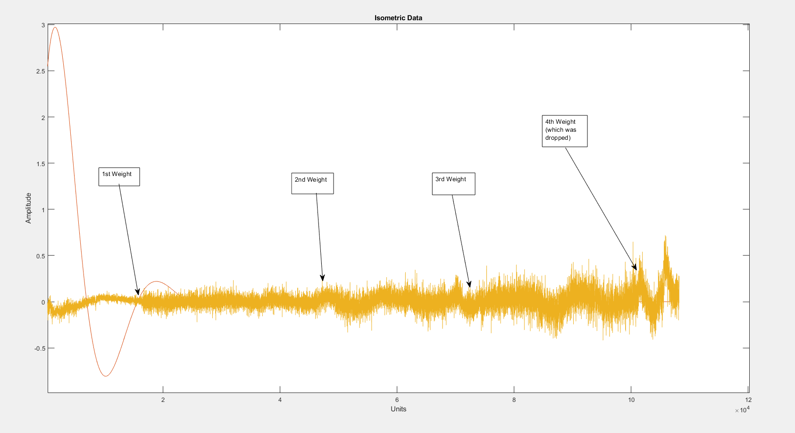

Figure 1: Isometric Data

c. Calculate the RMS envelope of the signal using a sliding 1s analysis window. nb. sliding 1s analysis = moving average using 1s of data to calculate each value. Plot the RMS envelope calculated with the 1s analysis window.

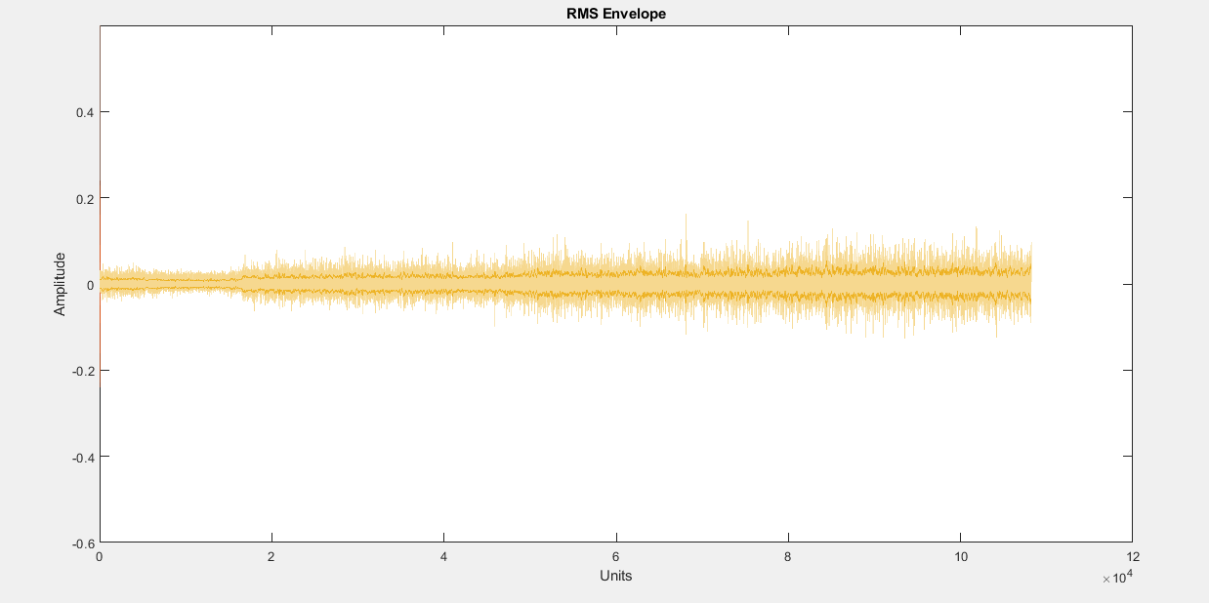

Figure 2: RMS Envelope with 1s Analysis Window (isometric)

d. For each 15s interval of lifting 1, then 2... books, what is the average RMS value of your signal? Plot it as a function of the number of books (x axis).

| # of books | RMS (µV ) |
| --- | --- |
| 1 | 0.0138 x 10-6 |
| 2 | 0.0206 x 10-6 |
| 3 | 0.0275 x 10-6 |
| 4 | 0.0297 x 10-6 |

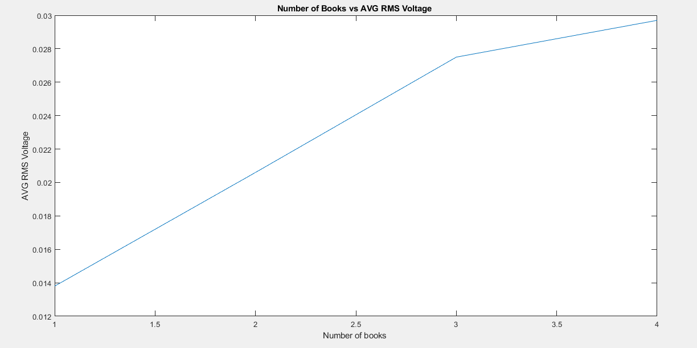

Figure 3: Number of Books vs AVG RMS Voltage (Volts)

e. (Max. 100 words) What happens to the number of activated motor units and their firing rates when the weight is increased?

As the weight increases, the number of activated motor units increases. This is because more muscles are required to carry the weight, and therefore more motor units must be activated to reach more muscles. This is called spatial recruitment. Another way to successfully hold the weight is to increase the firing rate of one motor unit. By increasing firing rate, one motor unit is able to do more, thus increasing the efficiency of a single unit. This is called temporal recruitment. The combined effect leads to more activated motor units, that are all more efficient.

**3.0 - Isotonic Contractions**

a. Plot the signal of the bicep_isotonic file and identify the time instances when the muscle length is varied. Plot the RMS envelope calculated with the 1s analysis window.

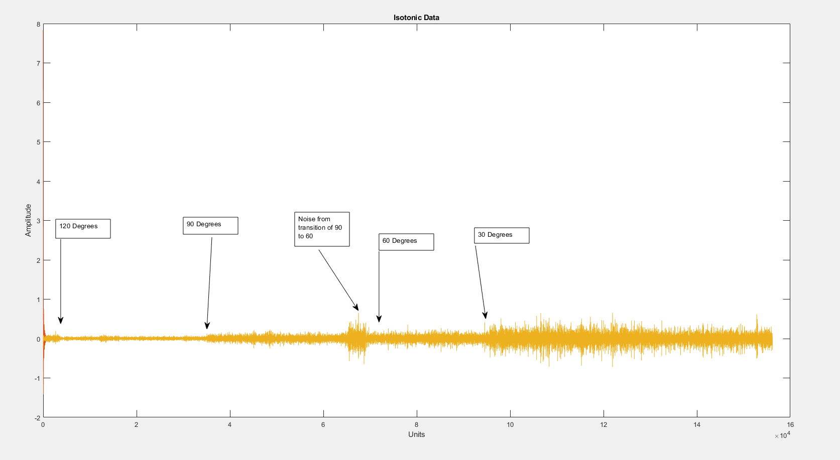

Figure 4: Isotonic data

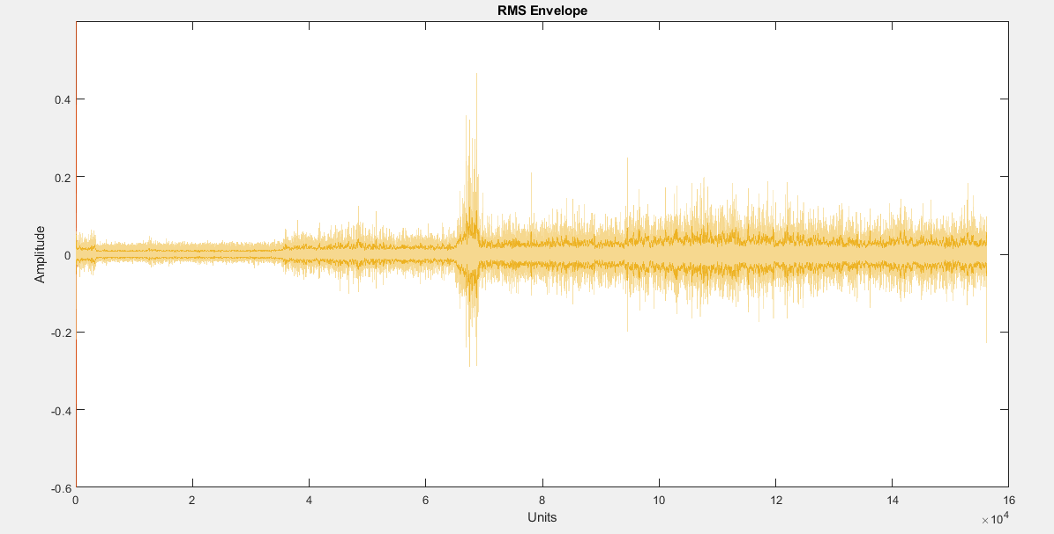

Figure 5: RMS Envelope with 1s Analysis Window (isotonic)

b. What is the average RMS value of your signal for each position (ignoring time when the arm is moving from one position to another)? Plot the value (y axis) as a function of the angle (x axis).

| Arm angle (degrees) | Average RMS (µV ) |
| --- | --- |
| 120 | 0.0111 x 10-6 |
| 90 | 0.0276 x 10-6 |
| 60 | 0.0363 x 10-6 |
| 30 | 0.0661 x 10-6 |

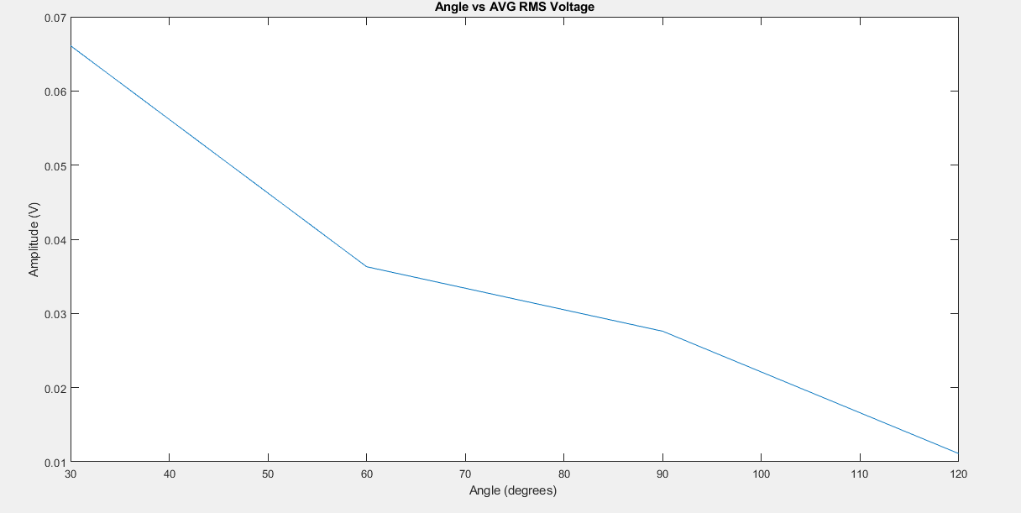

Figure 6: Angle of Arm vs AVG RMS Voltage

c. (Max. 100 words) What changes occur in your muscle to create the shape of the plot in question 3b? Draw the sliding filament model diagram of a muscle fibre and use this model to support your answer.

The graph in question 3b is in reference to the concentric contraction that is occurring when the angle of the bicep to foreman is decreased from 120 degrees to 30 degrees. Concentric contraction is a muscle contraction that shortens the length of the muscle fibers. When this contraction is under a load like it was in the lab it will take the recruitment of more muscle units the smaller the angle becomes. Thus, the more muscles that are recruited the greater Vrms is which is why the plot has a semi linear shape.

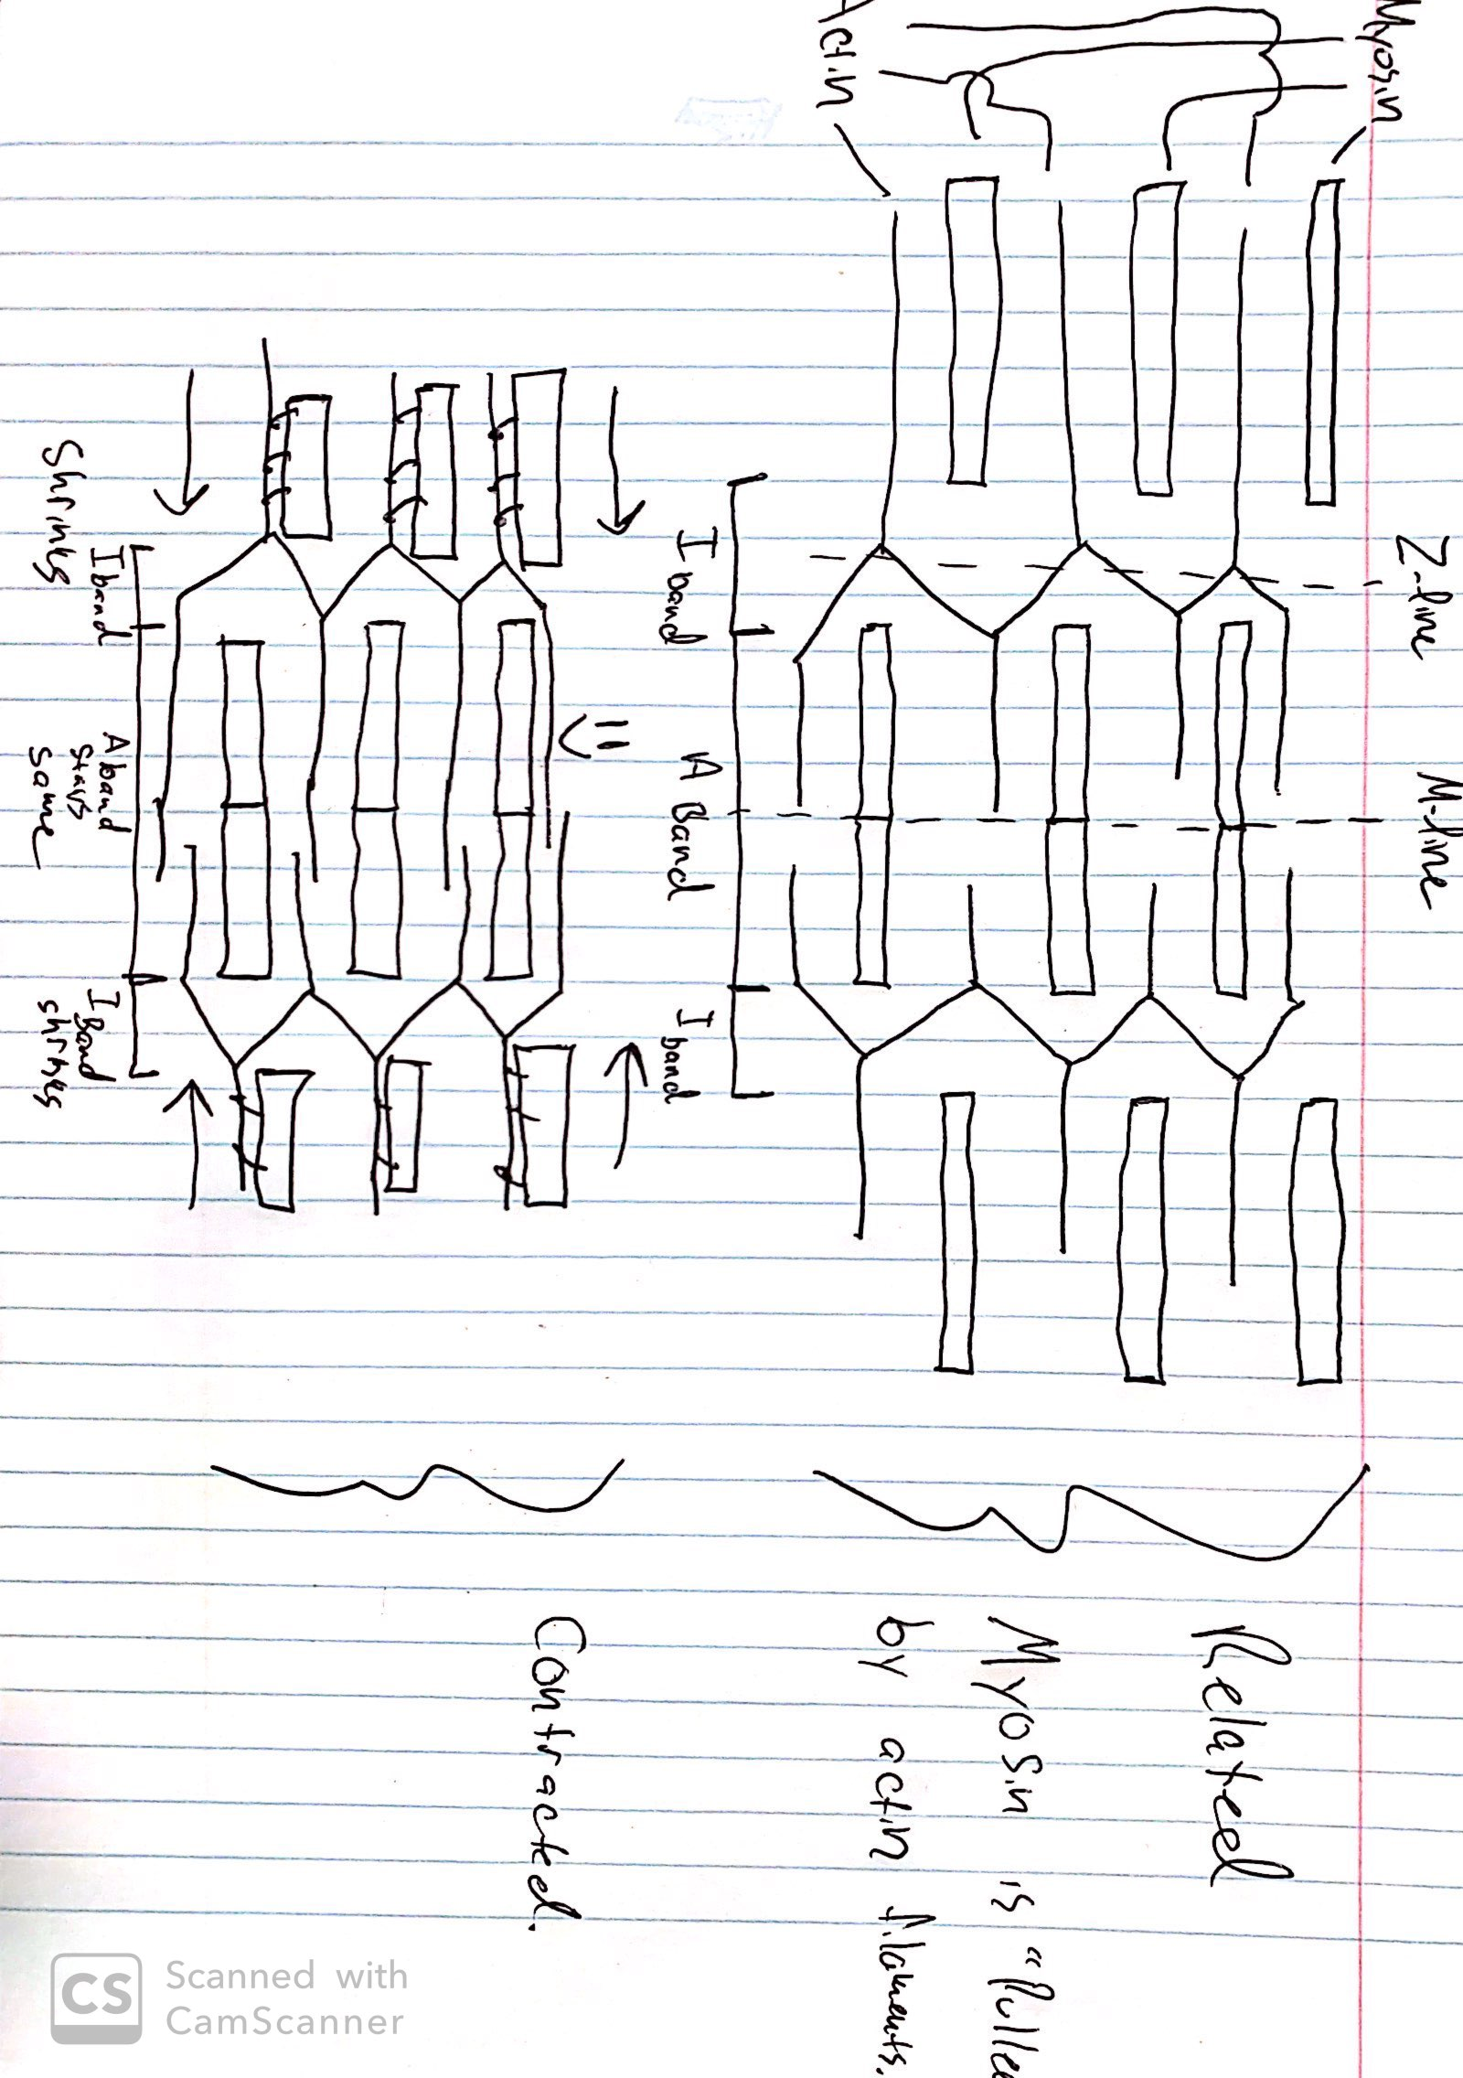

Figure 7: Sliding Filament Model